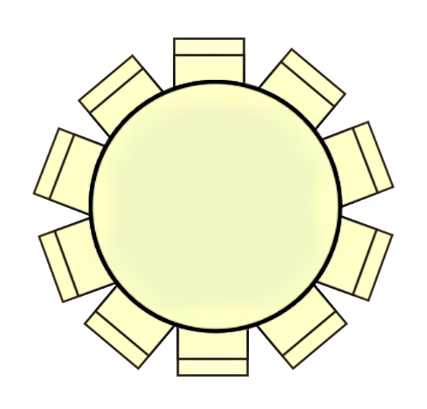  Table 1  Seat 7  Seat 2  Seat 4  Seat 10  Seat 8  Seat 9  Seat 6  Seat 5  Seat 3  Seat 1 | Seat 2  Seat 10  Seat 7  Seat 9  Seat 4  Seat 5  Seat 8  Seat 6  Seat 3  Seat 1  Table 2
Seat 5  Seat 8  Seat 3  Seat 1  Table 3  Seat 2  Seat 10  Seat 6  Seat 7  Seat 9  Seat 4 | Table 4  Seat 10  Seat 6  Seat 7  Seat 9  Seat 3  Seat 4  Seat 5  Seat 8  Seat 2  Seat 1
Seat 1  Table 5  Seat 10  Seat 6  Seat 7  Seat 9  Seat 2  Seat 4  Seat 5  Seat 8  Seat 3 | Table 6  Seat 10  Seat 6  Seat 2  Seat 7  Seat 9  Seat 4  Seat 5  Seat 8  Seat 3  Seat 1

