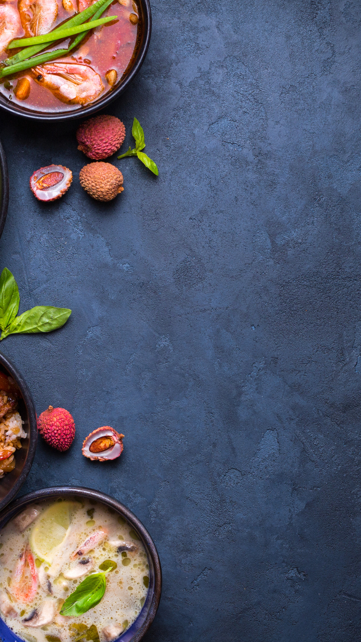
Our Special Menus

Menu Item Name | $00
Menu Description

Menu Item Name | $00
Menu Description

Menu Item Name | $00
Menu Description

Menu Item Name | $00
Menu Description

Menu Item Name | $00
Menu Description

Menu Item Name | $00
Menu Description

Menu Item Name | $00
Menu Description

Menu Item Name | $00
Menu Description

Menu Item Name | $00
Menu Description

