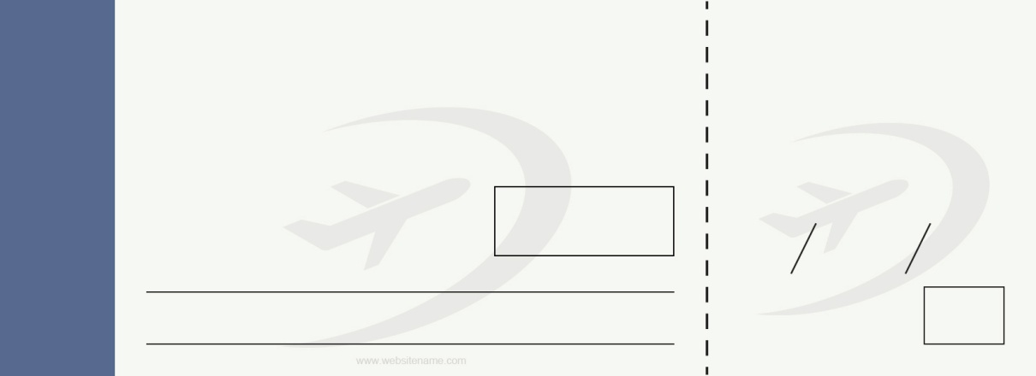



08 B
18-45
18-45
Boarding Till
B 54321
6 jan 2020
07
08 B
B 54321
6 jan 2020
07
lorem ipsum
lorem ipsum
lorem ipsum
lorem ipsum
lorem ipsum
lorem ipsum
Seat
Flight
Date
Gate
To
From
Name of passenger
Boarding Till
Seat
Flight
Date
Gate
Name of passenger
From
To
AIRLINE NAME
BOARDING PASS
AIRLINE NAME

