**Girlfriend Application**



**Contact Information**

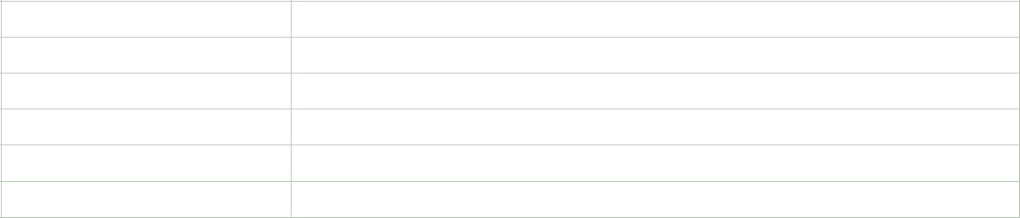

Name

Street Address

City ST ZIP Code

Home Phone

Work Phone

E-Mail Address



**Availability**

During which hours are you available to go on dates?

___ Weekday mornings ___ Weekend mornings

___ Weekday afternoons ___ Weekend afternoons

___ Weekday evenings ___ Weekend evenings



**Interests**

Tell us in which areas you are interested in as a date

___ Movies

___ Fancy Dinner

___ McDonald’s

___ A Walk on the Beach

___ Simply Hangout

___ Cuddle up and stay in

___ Hit the gym

___ Go shopping



**Special Skills or Qualifications**

Summarize special skills and qualifications you have acquired from dating,through other activities, including hobbies or sports.





**Previous Dating Experience**

Summarize your previous Dating experience.



**Person to Notify in Case of Emergency**

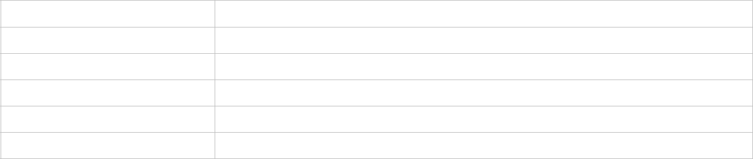

Name

Street Address

City ST ZIP Code

Home Phone

Work Phone

E-Mail Address



**Agreement and Signature**

By submitting this application, I affirm that the facts set forth in it are true and complete. I understand that if I am accepted as a girlfriend, any false statements, omissions, or other misrepresentations made by me on this application may result in my immediate dismissal.

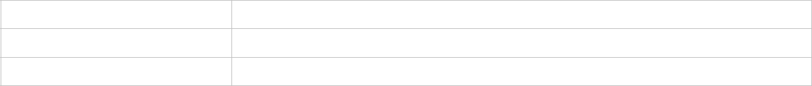

Name (printed)

Signature

Date



**Our Policy**

It is the policy of this organization to provide equal opportunities without regard to race, color, religion, national origin, gender, sexual preference, age, or disability.

Thank you for completing this application form and for your interest in dating with me.